Using SharePoint for Assignments

**Contents**

Setup 3

Teams 3

SharePoint 3

List 4

Create 4

Modify 5

Permissions 5

List Columns 6

Add Pupils 8

Document Library 9

Create 9

Modify 10

Permissions 10

Power Automate – Create & Share 11

Create Flow 11

Code 12

Manually trigger a flow 12

Get Items 12

Apply to each 13

Create new folder 13

Grant access to an item or a folder 13

Run the Flow 14

Power Automate – Remove access to Folders 15

Duplicate Flow 15

Edit Flow 15

Send an HTTP request to SharePoint 16

Turn on and Run 16

Power Automate – Grant access to Folders 17

Duplicate Flow 17

Edit Flow 17

Turn on and Run 17

# Setup

## Teams

Create a new class team. This one is called **Test**.

## SharePoint

In the SharePoint site of the class team, create a list and a document library.

SharePoint can be accessed via the **General** channel and the **Files** tab. It can take a few minutes after the team is created for the site to be accessible.

Access the **Site contents**.

### List

#### Create

Create a new list.

The list is called **Data**. It is used to hold the details of the pupils.

#### Modify

##### Permissions

Access the site contents to edit the settings of the list.

Stop inheriting permissions.

Remove non-owners.

##### List Columns

Show the **ID** column.

Add a *Person* column.

This one is called **Pupil**.

#### Add Pupils

Add the required pupils.

Glow email addresses can be used.

Update *Title* to match *ID*.

### Document Library

#### Create

Create a document library using the same steps for creating a list.

The document library is called **Assignment**. It is used to hold the pupils’ files.

#### Modify

##### Permissions

Modify the permissions and remove non-owners using the same steps for the list.

# Power Automate – Create & Share

Power Automate will require the site address of the SharePoint site:

The address will be shown in various drop-down lists.

## Create Flow

Create a flow.

This one is called **Test Create & Share**.

## Code

### Manually trigger a flow

### Get Items

### Apply to each

### Create new folder

### Grant access to an item or a folder

## Run the Flow

Save and run the flow

Check the result.

# Power Automate – Remove access to Folders

## Duplicate Flow

This one is called **Test Unshare**.

## Edit Flow

Change the *Apply to each* block:

### Send an HTTP request to SharePoint

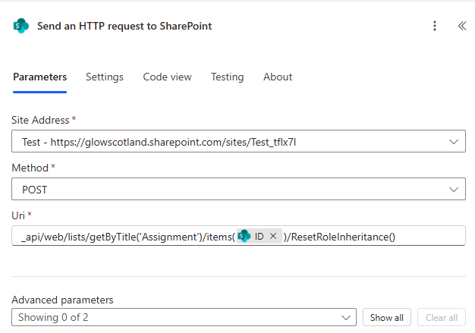

Uri:

_api/web/lists/getByTitle('Assignment')/items(@{items('Apply_to_each')?['ID']})/ResetRoleInheritance()

## Turn on and Run

Turn on the flow.

Run the flow.

Check the result.

# Power Automate – Grant access to Folders

## Duplicate Flow

This one is called **Test Share**.

## Edit Flow

Change the *Apply to each* block:

## Turn on and Run

Turn on and run the flow. Check the result.

